6**. SINE WAVE GENERATOR USING OPERATIONAL AMPLIFIER**

* 1. **OBJECTIVE**

Design a sine wave oscillator using operational amplifier

* + 1. RC phase shift oscillator
    2. Wien bridge oscillator
  1. **HARDWARE REQUIRED**

|  |  |  |  |
| --- | --- | --- | --- |
| **S.No** | **Equipment/Component name** | **Specifications/Value** | **Quantity** |
| 1 | IC 741 | Refer data sheet in appendix | 1 |
| 2 | Cathode Ray Oscilloscope | (0 – 20MHz) 1 | 1 |
| 3 | Resistors | 330 Ω  1.5K Ω  15K Ω  1M Ω  4.7K Ω  18K Ω  10K Ω  15K Ω  18K Ω | 1  4  1  1  1  1  2  1  1 |
| 4 | Capacitors | 0.1µf  .01µf | 2  2 |
| 5 | Regulated power supply | 15 V | 1 |

### RC phase shift oscillator

The feedback network consists of three identical RC sections. Each section produces a phase shift of 60o Therefore, the net phase shift of the feedback is 180 o the amplifier stage introduces a phase shift of 180 o Therefore, the total phase shift between the input and output is 360 o or 0 o. When the circuit is energized, by switching on the supply, the circuit starts oscillating. The oscillations will be maintained if the loop gain is at least equal to unity.

Feedback fraction of the RC phase shift network

=1/29

The frequency of oscillation f0=1/2 πRC6.

### Circuit diagram

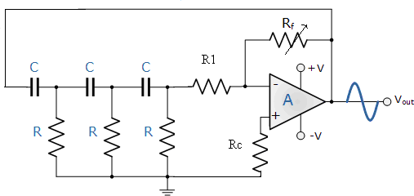

C=0.1µF, R=1.5K, R1=15K, RF=1M pot

### Design:

f0=1/2 πRC6 Rf ≥ 29R1

R1 ≥ 10R

Choose C =0.1µF f0 = 500 Hz

|  |  |  |  |
| --- | --- | --- | --- |
| *R* = | 1 | = | 1 |
|  | 6x2*πf*0*C* | 6x2*πx*500*x*0.1*x*10−6 | |

R = 1.3 KΩ

Choose R = 1.5KΩ

R1≥15KΩ (to prevent loading) Therefore, R1 = 10R = 15KΩ

Rf = 29R1=29x15KΩ=435KΩ (Use 1MΩpot)

### Wien Bridge Oscillator

It is commonly used in audio frequency oscillator. The feedback signal is connected in the input terminal so that the output amplifier is working as a non-inverting amplifier. The Wien bridge circuit is connected between amplifier input terminal and output terminal. The bridge has a series R network, in one arm and a parallel RC network in the adjoining arm. In the remaining two arms of the bridge, resistor R1 and Rf are connected. the phase angle criterion for oscillation is that the total phase shift around the circuit must be zero. This condition occurs when bridge is balanced. At resonance frequency of oscillation is exactly the resonance frequency of balanced Wien bridge and is given by f0 = 1/ (2πfC).assuming that the resistors are input impedance value and capacitance are equal to the value in the reactive stage of Wien bridge. At this frequency, the gain required for sustained.

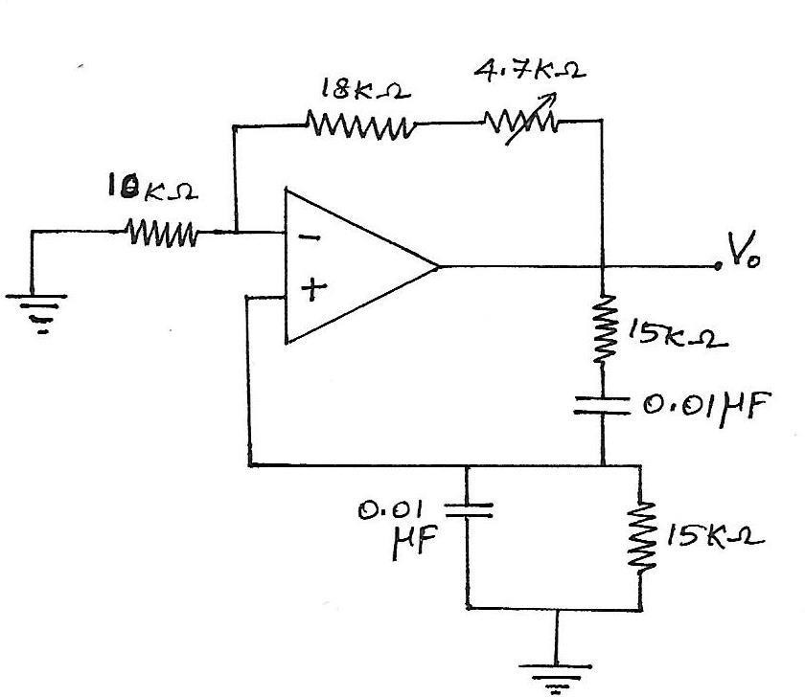

### Design

Given, fo = 1KHz; Assume C = 0.0015µF fo = 1/(2π RC),

R = 100KΩ

Rf = 2R = 200KΩ

### Design Constraints

* The loading effect of the amplifier on the feedback network has an effect on the frequency of oscillations and can cause the oscillator frequency to be up to 25% higher than calculated. Then the feedback network should be driven from a high impedance output source and fed into a low impedance load such as a common emitter transistor amplifier but better still is to use an [Operational Amplifier](http://www.electronics-tutorials.ws/opamp/opamp_1.html) as it satisfies these conditions perfectly.
* The voltage gain of the Wien bridge oscillator circuit must be equal to or greater than three “Gain = 3″ for oscillations to start.
* Due to the open-loop gain limitations of operational amplifiers, frequencies above 1MHz are unachievable without the use of special high frequency op-amps.

| Oscillator | Amplitude | Time period | Frequency (Design) | Frequency (Observed) |
| --- | --- | --- | --- | --- |
| RC Phase Shift |  |  |  |  |
| Wein Bridge |  |  |  |  |

### PRE-LAB

* + 1. In an op-amp based RC phase shift oscillator, what is the minimum gain that should be maintained. Why?

2. State Barkhausen criterion for oscillation

3. Write the formula to calculate frequency of oscillation for RC &Wien bridge oscillator

4. What are the applications of oscillators?

5. In RC phase shift oscillator using, the value of capacitor is 0.01µF and the

Frequency of oscillation is 35 KHz. the voltage gain of the amplifier

Should be 30.calculate the value of R of RC feedback Network?

### POST-LAB

1. What are the merits and Demerits of Wien bridge oscillator?
2. Why do we need three RC networks for a phase shift oscillator?
3. Explain the main difference between an amplifier and an oscillator.
4. In as RC phase shift oscillator, if R1 = R2 = R3 = 200kΩ and C1 = C2 = C3 = 100pF. Find the frequency of oscillation.
5. Mention the advantages and disadvantages of negative feedback.

**Result:**